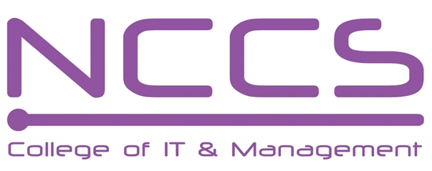
National College of Computer Studies
(NCCS-College of IT & Management)

Final Examination (2021)
BSc.CSIT/First Semester/ CSC-109 : Introduction to Information Technology

Candidates are required to answer the questions in their own words as far as practicable.

Full Marks: 60
Pass Marks: 30
Time: 3 Hours
Set A

Long Questions:
Attempt any two Questions: [2×10=20]
- Discuss file processing and database processing. What are the benefits of using database processing over file processing? Discuss different types of DBMS.
- Explain the different type of modulation with suitable figure.
- Explain the network topology. What are the different types of network topologies?
Short Questions:
Attempt any eight questions [8×5=40]
- What is the role of Control unit in CPU? How analog computer differs from digital.
- What is difference between RISC and CISC?
- Explain briefly about any three input device.
- What is cache memory and how it works ?
- Explain database normalization with example.
- Define CIA Security Triad.
- What are the different types of software used in the computer systems?
- Why IP Address is used in internet? Mention the significance of domain name in internet.
- What is GIS? Discuss different GIS technologies.
- What is Multimedia? Explain the application of the multimedia.

********
Note: Please send your answer sheet to the following e-mail address.
To: csit10batch@nccs.edu.np
CC: khushi.soni4u@gmail.com

